**Assignment 1**

1. What is JDK? JRE? JVM?

JDK - Java Development Kit which provides the environment for user to develop and execute (run) program. It includes JRE and development tools.

JRE - Java Runtime Environment which provides the environment for user to execute (run) program only. It includes JVM and supporting files.

JVM - Java Virtual Machine which coverts bytecode to machine code to execute program. Major role to implement WORA (Write Once Run Anywhere).

1. What is java compiler?

The Java compiler is a program to compile the code from source code which program by programmer to platform-independent Java file. For example: Java Programming Language Compiler (javac).

1. Why is java platform independent?

The platform independent is that the java compiled code (byte code) can run on all operating systems. The result of the Java compiler is the .class file or the bytecode and not the machine native code (unlike C compiler). Then the interpreter is the JVM and thus the Bytecode is executed by the JVM to machine code.

1. What is IDE? Why is it important for developers?

IDE is Integrated Development Environment. It provides environment includes functions such as debugging or executing to programmer. It increases the programmer productivity.

1. Is java case sensitive?

Yes, the upper or lower case of letters in the Java programs matter.

1. What do the following key words do?

static - the key word in front of methods or attributes which can be accessed without create a new object.

final - the key word in front of classes, methods, or attributes which restrict inherit, override, and change.

public, private - modifiers provide different access right, showing below.

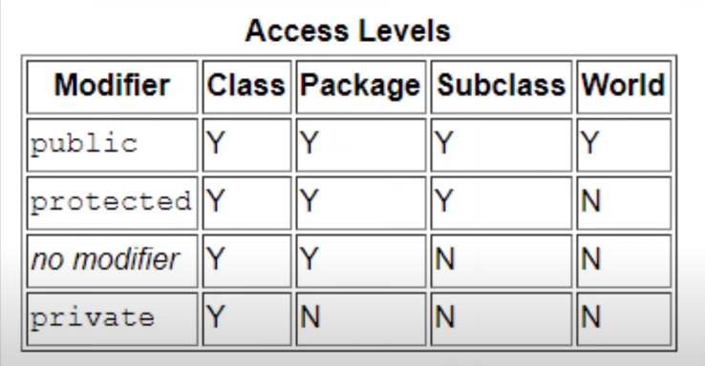

void - key word in front of the method which is without return anything.

null - the variable does not refer to any object.

package - declare a new package.

Class - declare a new class.

new – create a new object (in heap memory)

1. What is primitive type and reference type?

primitive type - basic data types which include byte, short, int, long, float, double, char, boolean

reference type - A variable of class type is called reference data type. It contains the address (or reference) of dynamically created objects. For example: String.

1. Is parameter passed by value or reference?

By value. By value for built-in types, and by value of the pointer for object types.

1. What is the output: System.out.println(1 > 0 : “A”:”B”);

Sytax error. If it replace to (1 > 0 ? “A”:”B”), the output is A.

1. How to define constants in java?

static final datatype name = constant;

* The static modifier causes the variable to be available without an instance of its defining class being loaded
* The final modifier makes the variable unchangeable.

1. What is String? Is it primitive type?

Strings in Java are Objects (immutable class) that are backed internally by a char array.

It’s not primitive type.

1. How to check if a String is representing a number?

We can traverse (for loop) each char in String by using isDigit() method to check (charAt()), if all char fit condition return true, else return false.

1. Write a program to implement the following activity diagram:

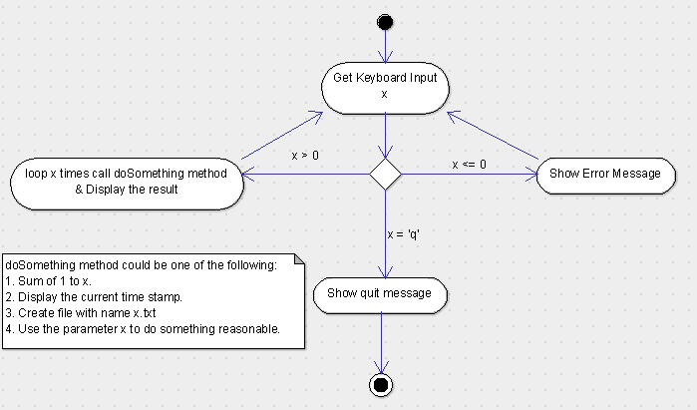

1. Write a program to merge two arrays of int.

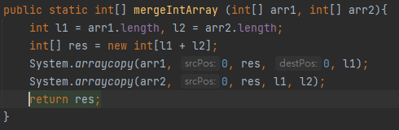

1. Write a program to find the second largest number inside an array of int.

